Matayla Lewis linkedin.com/in/mataylalewis 
Technical Support Engineer and Service Desk Lead

EXPERIENCE
Helpdesk Lead (Tier 1 Supervisor) & Helpdesk Consultant II (Tier 2), Academic Technology Services, Office of Information Technology, Portland State University, Portland, OR
Aug 2017 - Present
- Manage operations & coordinate management of cross-functional support teams in a collaborative enterprise environment of a complex institutional organization
- Monitor metrics & evaluate feedback from both internal & external customers to design & implement service delivery models optimized to meet organizational goals & values
- Engineer processes & develop solutions to best resolve problems while understanding & addressing requirements & recommendations of stakeholders & organizational partners
- Lead strategic projects to improve needed infrastructure & integrate innovative practices
- Empower technical service teams with the expertise, communication skills, documentation, systems, & resources to grow strong & successful support relationships with users & partners
Help Center Associate (Tier 2) & IT Specialist, Client Services, Information Technology Services, University of Nebraska-Lincoln, Lincoln, NE
Aug 2013 - Jul 2017
- Demonstrated expertise in a fast-paced environment to efficiently resolve problems & facilitate requests through excellent & professional customer service & communication skills as well as advanced technical understanding of available technological solutions, products, & services.
- Helped monitor security of infrastructure & network of organizational operations through advanced reporting & insights concerning potential security vulnerabilities
- Collaborated with team members to implement enterprise best practices & interact with stakeholders to develop partnerships & optimize service strategy to meet rapidly changing technical needs of a highly innovative & competitive learning community
Online Learning Administrative Support Specialist & Lab Attendant, Office of Information Technology, Portland State University, Portland, OR
Jun 2012 - Jul 2013
- Collaborated with team members to provide excellent service, develop or improve stakeholder relationships & efficiently resolve complex technical problems in a fast-paced environment
Graduate Research & Teaching Assistant, College of Urban & Public Affairs, Portland State University, Portland, OR
Sep 2011 - Jun 2013
- Implemented advanced methodologies to analyze data and create documentation to further dialogue existing knowledge & research as well as help facilitate education of emerging scholars
Senior Applecare Advisor (Tier 2) & Applecare Advisor (Tier 1), Affiliated Computer Services, a Xerox company, Portland, OR
Oct 2008 - Oct 2011
- Collaborated with team members to efficiently resolve technical problems & respond to customer inquiries in a highly competitive, rapidly evolving, & fast-paced technical support environment
- Monitored & documented emerging technical issues & directly engaged developers & engineers
Technology Representative & Computer Lab Attendant, College of Education & Pierre Laclede Honors College, University of Missouri-Saint Louis, St. Louis, MO
Oct 2006 - May 2008
- Built & maintained lasting relationships with customers through demonstrated technical expertise, excellent communication, & high-quality service interactions in a collaborative space
Resident Assistant & Mentor , Office of Residential Life and Housing, and Assistant Coordinator, Emerging Leaders Mentorship Program, Office of Student Life and Involvement, University of Missouri-Saint Louis, St. Louis, MO
Dec 2005 - May 2007
- Engaged students through active listening & innovation activity implementation in a learning environment while monitoring physical security & maintenance of residential community
Emergency & Outpatient Registrar, Admitting, St. Elizabeth's Hospital, Belleville, IL
March 2004 - Aug 2006

Efficiently engaged customers to provide information needed to meet both organizational priorities & values in a high-stress fast-paced environment

CERTIFICATIONS
ITIL Foundations 4 (Pink Elephant, 2020), ITIL Foundations 3 (Pink Elephant, 2019), Business Process Data Modeling (Global Knowledge, 2018), Advanced Business Process Analysis (Global Knowledge, 2018), Business Process Analysis Essentials (Global Knowledge, 2018), CompTIA A+ - Technician (CompTIA, 2015), Dell Certified Systems Expert (Dell,Inc., 2014), JAMF Pro Essentials for Apple Devices (JAMF, 2014), Administering System Center Configuration Manager Essentials (Microsoft, 2014), Apple Certified Help Desk Specialist (Apple, Inc., 2010), AppleCare Expert (Apple, Inc., 2009), Microsoft Office Suite Expert (Robert Half, 2004)

PROFESSIONAL DEVELOPMENT
Everything DISC® Assessment, (DiSCProfile.com, 2021 & 2019), HR Manager Basics Training Series, (Portland State University, 2018), Strengthsfinder, (Clifton Strengths, Gallup, 2018), Emotional Intelligence, (Center for Executive and Professional Education, Portland State, 2017), Graduate Field Comprehensive Exams, (College of Urban & Public Affairs, Portland State University, 2013), Conflict Resolution Introduction, (Portland State University, 2010), Emerging Leaders Mentorship Program (Emerging Leaders Foundation, 2005)

EDUCATION
Master of Science in Applied Data Science for Business, School of Business, Portland State University, Portland, OR
(In Progress)
Master of Science in Political Science (ABT), Portland State University, College of Urban & Public Affairs, Portland, OR
Sep 2011 - Jun 2013
Bachelor of Interdisciplinary Studies, College of Arts and Sciences,University of Missouri-Saint Louis, St. Louis, MO
Aug 2005 - May 2008
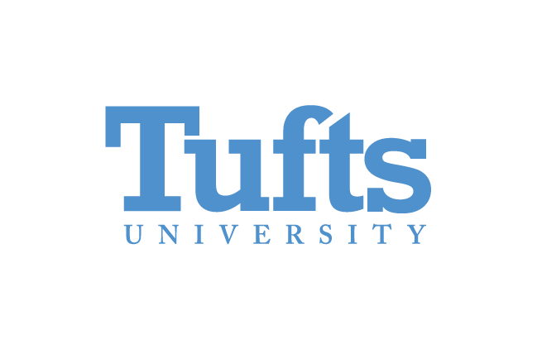Environmental Education & Leadership Internship Program, Institute for the Environment, Tufts University, Boston, MA
May 2003 - Aug 2003
Capital Scholars Honors Program, University of Illinois at Springfield, Springfield, IL
Aug 2002 - May 2005

